Overview

During the workshop, you will be playing and creating text adventures. There are between four and six tasks that you may perform.
If there’s enough time

Play a game (text adventure)

Quest version 5.2 will already be installed for you. If you wish to run Quest at home, it can be downloaded from http://www.textadventures.co.uk/. The website also includes forums, documentation, tutorials and games you can download.
You should play the Quest based game ‘Persian Adventure’. You will be shown how to load this.
You may double click on the game file called ‘Persian_adventure.aslx’. If you do, then the Quest screen may look like:
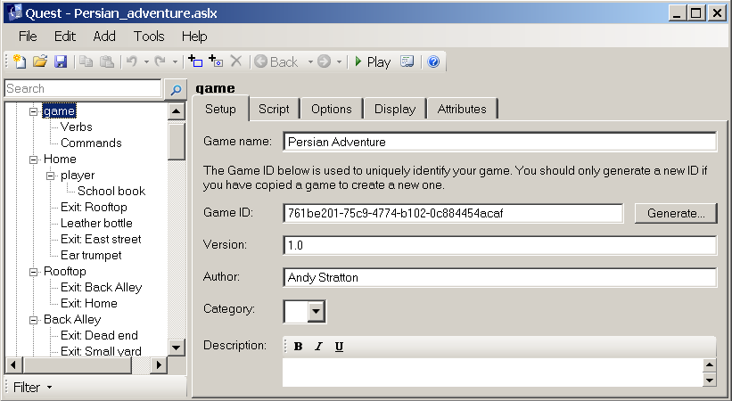
You need to click on the ‘Play’ icon at the top:
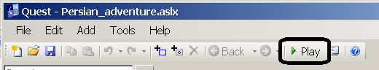

Note: If you finish the adventure easily or wish to see something a bit different, then please try ‘The Hitchhiker’s Guide to the Galaxy’ at http://www.bbc.co.uk/radio4/hitchhikers/game_nolan.shtml. Hopefully this will work during the workshop. If not, then please try it when you are at home.
N.B. This is a much harder (and much more extensive) adventure game that includes graphics and also humour . You have to type in all your commands, which makes it harder to use – but the Babel fish problem is a classic puzzle…

Design your own (adventure)
Please fill in this form when you have finished playing the game.
Note: If you are not sure what to put, please see the examples on the next page.
Where does the adventure (story/game) take place?
When is the adventure set?
Who is the player going to be in the adventure?
What will the player try to find/get/rescue/do?
What other characters are there?

What other places will the players visit?

What objects might the players find or use?

Draw a map of the main locations

Example designs

Where does the adventure (story/game) take place? | In a fantastic Persia
When is the adventure set? | A long time ago
Who is the player going to be in the adventure? | A poor boy or girl
What will the player try to find/get/rescue/do? | Find their father
What other characters are there? | Mother, Father, Evil wizard, Djinn (genie)
What other places will the players visit? | Marketplace, desert, cavern
What objects might the players find or use? | Magic lamp, water bottle, flying carpet, ladder

Where does the adventure (story/game) take place? | In the President’s brain
When is the adventure set? | During the cold war
Who is the player going to be in the adventure? | A Russian germ
What will the player try to find/get/rescue/do? | Get the president to stop a nuclear war
What other characters are there? | President Lincoln (representing good) and Richard Nixon
What other places will the players visit? | Childhood memories, The subconscious, Motor Control
What objects might the players find or use? | Random thoughts, Aggression, Red blood cells, Sugar, Oxygen

Rooms Tutorial
N.B. Follow the instructions exactly, or you will likely
find you can’t complete the tutorial.
e.g. if you use a different name for a room, then all
the following instructions will be wrong.

Starting a new game with Quest
After running Quest, follow the steps below to create a new adventure:
- You need to start a ‘New Game’:
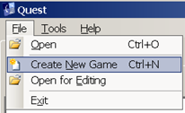 or 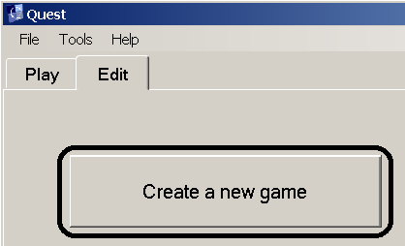
- Make sure that the Game Type is ‘Text Adventure’, then type in a name for your game and select OK:
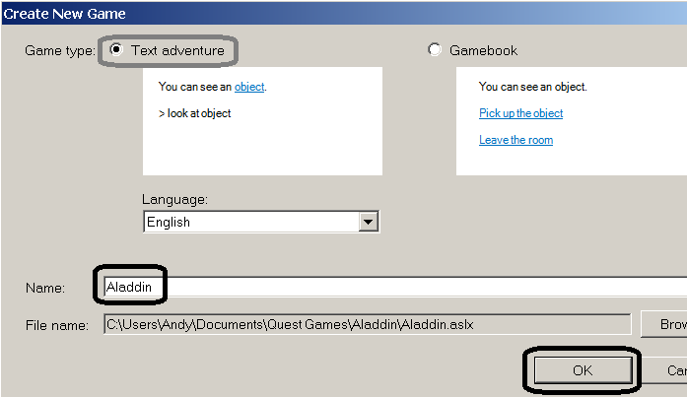
- Wait for a short while as your game is created:
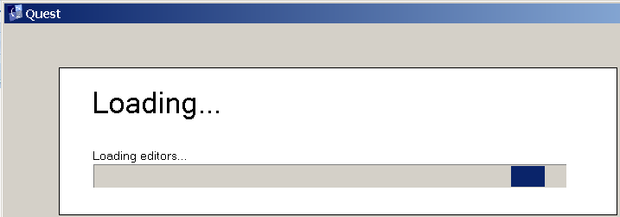
- When the game is loaded, enter your name as the author:
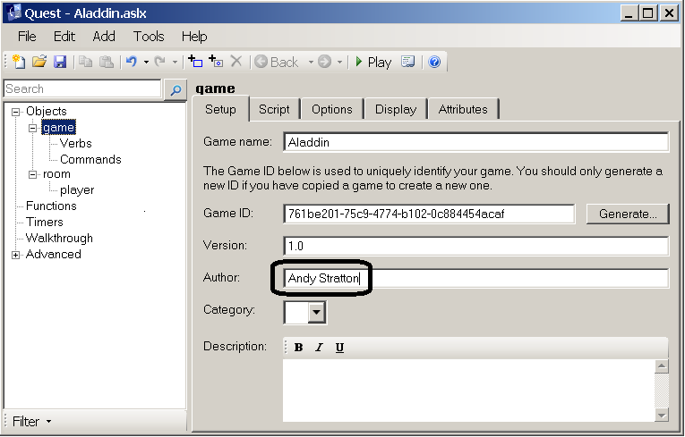
- Now choose to ‘Play’ the game:
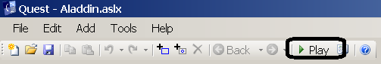
- You will be prompted whether to ‘save’ your changes - choose Yes:
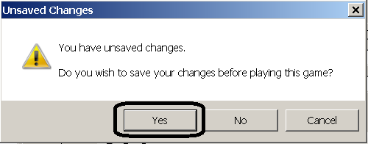
- You can now see your (almost empty) game:
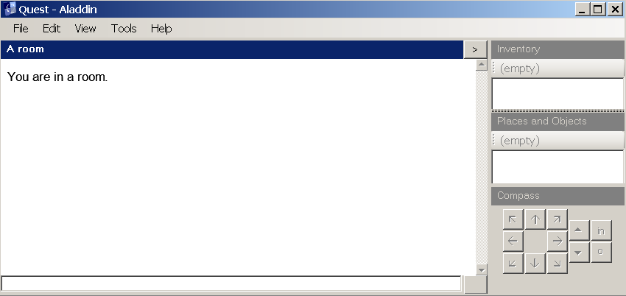
- Choose ‘Stop Game’ to return to the editor:
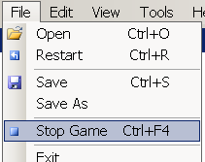

Editing the standard Room
The room we’re given for free needs to be much more interesting, so:
- Click on ‘room’ in the ‘Objects’ list on the left:
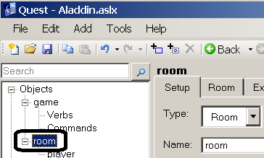
- Now change the name to ‘Home’:
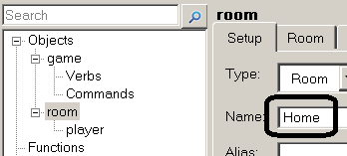
- Now ‘Play’ the game:
- Oh well. Stop the game
- We need to change the ‘prefix’, the bit that Quest is putting in front of the room name and then play the game. Untick the option to ‘Use default prefix and suffix’:
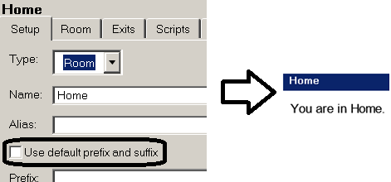
- Now the ‘title’ at the top of the ‘output’ pane is fine, but the description is wrong in the text.
- Stop the game.
- Switch to the ‘Room’ tab:
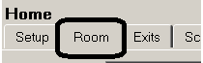
- Change the Description Prefix to say ‘at’ instead of ‘in’:
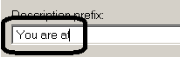
- Play the game:
- Stop the Game (please assume this when you need to edit the game)
- Now let’s add a description of the room (place/location) you are in by adding to the Description (on the Room tab):
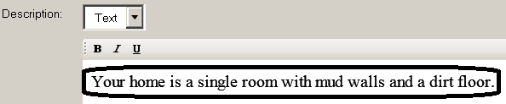
- Now play the game:
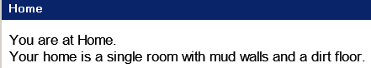

Adding Rooms (places)
We need some more rooms.
- Choose to ‘add room ‘:
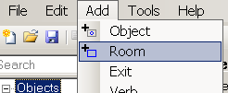
- Enter a name, a title, for the room and choose ‘OK’:
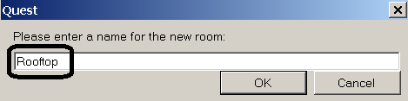
Note: Quest won’t allow you to use punctuation in a ‘name’. If you want to show a room name with punctuation, then set the ‘Alias’ for the room – this probably won’t make sense now – but may do later.
- Change the Description prefix (in the room tab) to say ‘You are on’:
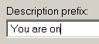
- To see the rooftop, in the left ‘object list’, drag the ‘player’ from ‘Home’ to ‘Rooftop’:
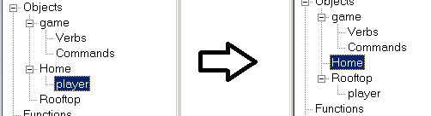
Note: The Rooftop will be shown collapsed – i.e. with a - you will need to click the ‘+’ to show the contents of the room.
- When you play, you will see the (empty) Rooftop description:

Moving from room to room
Text adventure games have a number of different directions you can move in, which are the four points of the compass (north, east, south, west), up/down and in/out. You can also use the ‘in between’ points of the compass - north east, south east, south west and north west – but these aren’t used in the examples for simplicity.
- Move the player object back to ‘Home’ (if you haven’t already) and Play. Note the directions in the bottom right:
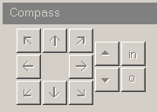
Note: up and down are shown by triangles and ‘o’ may be shown instead of ‘out’.
- Stop the game
- Click on the ‘Home’ room, then the ‘Exits’ tab:
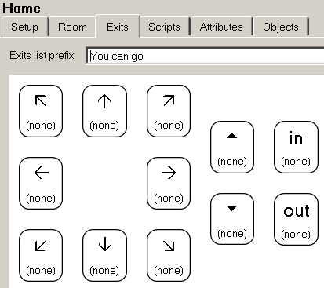
- Now click on the up triangle:
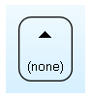
Note: Not the North Arrow
- This will show a panel on the right like this:
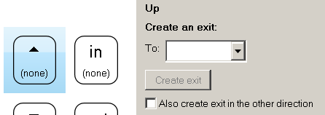
- Select the ‘drop down’ box and choose Rooftop:
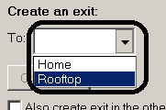
- Next tick (if it isn’t already) the ‘Also create exit in the other direction’:
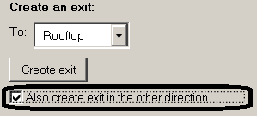
- Now choose ‘Create exit’:
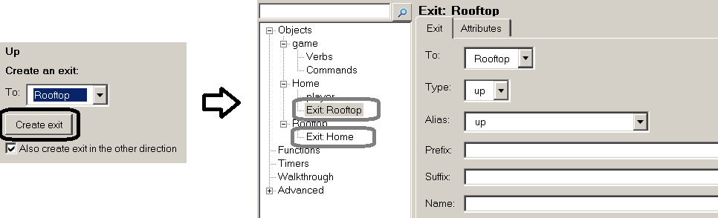
Note: Quest will show you the detail of the exit (as above), but we don’t need to do any more at the moment. This has now created an ‘up’ exit from home to the rooftop and a ‘down’ exit from the rooftop to home.
- Play the game. You will see that you have an exit shown in the text saying ‘You can go up’ and the up triangle is now available in the compass:
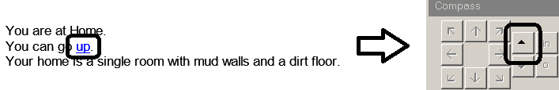
- Click on ‘up’:
- Click on the down triangle:
- Stop the Game.
- The descriptions for both rooms need changing. Change the home room description to include the bold text so that the player knows that there is a staircase:
‘Your home is a single room with mud walls and a dirt floor. Beside you are some mud built steps leading up to the roof.’
- Add a rooftop description:
‘You are standing on the top of your house, looking out on the street below. At the back of the house is an alleyway, to the south.’
- Play the game.

Moving in ‘different ways’ from room to room
Sometimes you will want to have an exit that does not work in the ‘opposite’ direction:
- Add a new room called ‘Back alley’ with a description of ‘The dried mud wall of your home rises above your head, peppered with stones like steps to the roof.’
- Select the ‘Rooftop’, exit tab, then add a ‘south’ exit to the back alley – make sure that ‘Also create exit in the other direction’ is NOT ticked:
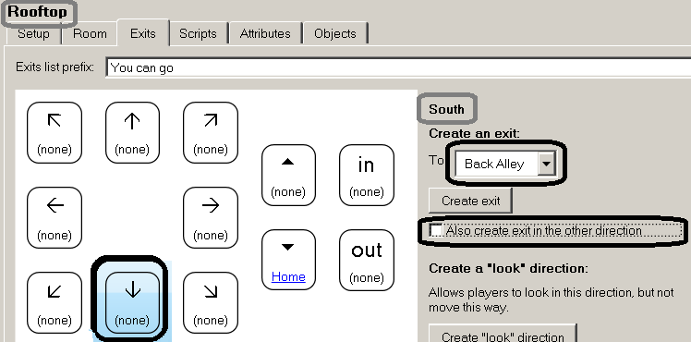
Note: Remember to click ‘Create exit’
- Now add an ‘up’ exit (without creating the exit in the other direction) from the ‘Back Alley’ to the Rooftop:
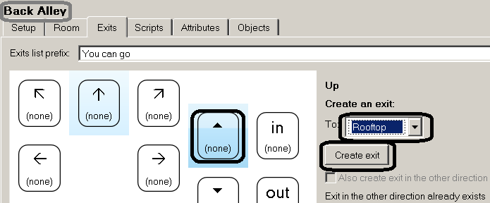
- Play the game and go south from rooftop and then up from the back alley.

4. Create your game

Design your own rooms
Note: Please start this task when you finish the above tutorial
Use the layout below to design how the rooms in your adventure are connected to each other. Don’t worry, yet, about ‘limiting’ where the player can go, e.g. if you plan to have a bridge where the player will have to pay to cross, then (for now) let the player go across.
Note: draw lines between rooms for the ‘compass directions’, with arrows if the exit is one way. You can also write a direction next to the line, e.g. u/d/i/o for up/down/in/out.
When you have about 4 linked locations:
Create your own (new) game, with a new name, in Quest and add rooms, descriptions and exits.

Optional - Adding an Introduction
Note: This is an extra tutorial that you can do if you are waiting to start the ‘Objects tutorial’.
An introduction can be used to set the scene and give some background about an adventure:
- Choose the ‘game’ object and then click the Script Tab
- Next click on ‘Add new script’:
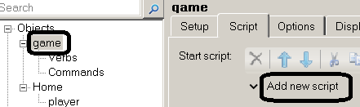
- Double click on ‘print a message’:
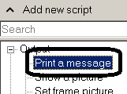
- Type in an introduction description, e.g.:
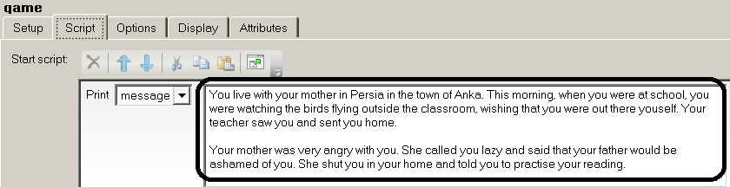
Note: You should put a blank line at the end of your introduction to make it look separate from the description of the first room.
- Play the game:
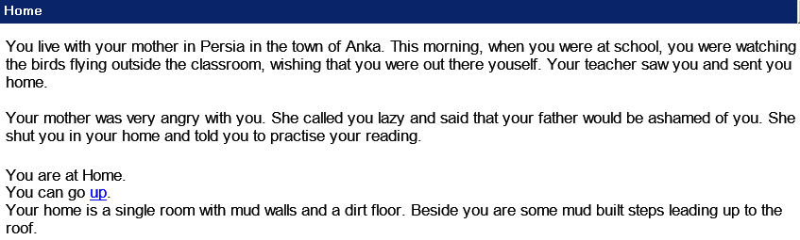
Now – open your own adventure game and add an introduction.

5. Objects Tutorial

Adding Objects
It is time to add some ‘objects’ to the rooms, e.g. tables, chairs, magic carpets, hyper dimensional space ship engines, pixie dust, etc.
- Open your Aladdin adventure.
- Click on ‘Home’ in the object list. This will decide where the object is placed when the game starts:
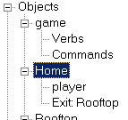
- Choose the ‘Add’ menu, then ‘Object’ OR the icon OR right click home->Add Object:
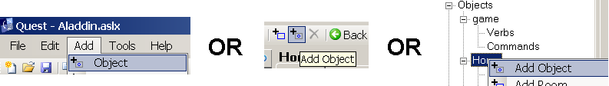
- Choose the name ‘Leather bottle’ and OK:
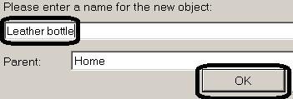
- The object list will now show the ‘Leather bottle’ inside the ‘Home’ room:
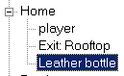
- Quest will also show you details of the object – some of which we will change later.
- Now play the game:
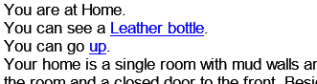
- Click on Leather bottle and select ‘Look at’:
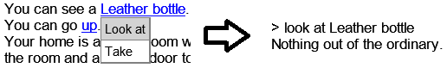
Note: This is the ‘default’ response that Quest will give for an object.
- Stop the game
- Select the bottle and the ‘Setup’ tab (if you need to).
- Choose to change the ‘Look at’ description (right down at the bottom of the page) to ‘Text’:
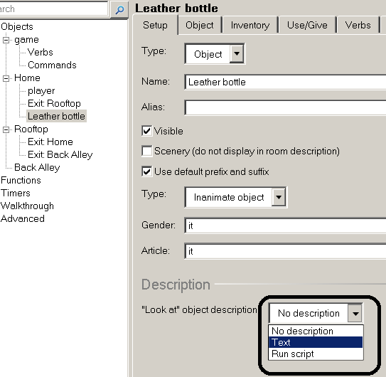
- Change the description to:
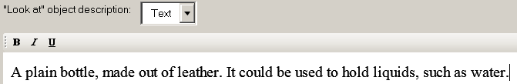
- Run the game and ‘Look at’ the bottle.
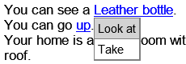
- Notice the result:

Allowing Objects to be picked up (taken)
The player can move around and see things, but it would be good to allow the player to take objects with them.
- Following on from the last steps, the object has also been added to ‘Places and Objects’ on the far right of the display. Click the bottle, then Take:
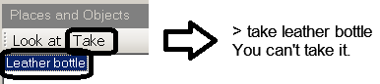
- Stop the game and click the bottle
- Select the ‘Inventory’ tab, then tick the option ‘Object can be taken’:
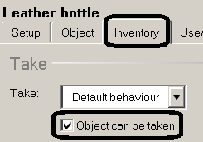
- Now Play the game and take the bottle:
- The bottle is now in your ‘inventory’, i.e. ‘what you are carrying’. This is shown at the top right:
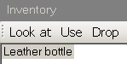
- Now go up and then south (to the back alley), then select the bottle and ‘Drop’ it:
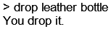
- Look at the ‘Places and Objects’:
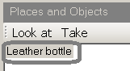
Note: You have take the leather bottle from ‘Home’ to the ‘Back alley’. But if you play the game again (from the beginning), the bottle will be back in ‘Home’.
Now – open your adventure game and add at least one object.

Starting objects
In the story, I would like the protagonist (main character) to start off with a school book, so:
- Click on the player in the object list and add a new object called ‘School book’:
- Click on the inventory tab.
- Untick the ‘Object can be dropped’ and add a description:
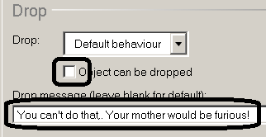
- Play the game. The inventory starts out with the book:
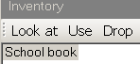
- Now try to drop the book:
- But the ‘Look at’ description is missing, so stop the game and add one (remember the description is down at the bottom of the page):
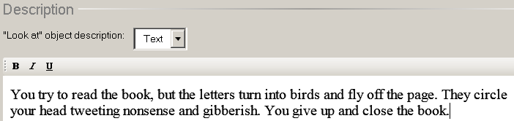
- There is also a problem, since the book can be ‘used’.
- Again, select the school book.
- Select the Object tab
- At the bottom are the inventory verbs. Click on ‘Use’ and then Delete it:
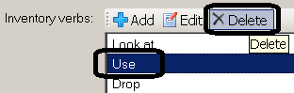
Note: The inventory verbs are things you can do with anything you are carrying.
- Play the game:
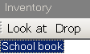
- Look at the book:
Now – open your game and add a starting object.

Using an object
The player can now pickup, drop and look at objects. But it is also useful to ‘use’ them in some way.
The example below allows us to use a stick to knock some fruit out of a tree:
- Add a new room called ‘Small yard’.
- Add a description of ‘A twisted plum tree grows in the middle of this yard. Hanging on the tree, just out of reach, are some plums.’
- Add a ‘both ways’ exit from the Back alley going west to the Small yard.
- Add a new object called ‘Stick’ on the Rooftop with a description of ‘A small twisted branch about the length of your leg. Your mother uses it to beat dust out the bed roll.’
- Tick the ‘can be taken’ option.
Note: So far we have only Quest how to describe things, where the player can move and what can be carried. Now we are going to do something more challenging. We are going to tell it a more complex instruction.
- Now select the Use/Give tab.
- Pick the ‘Run a script’ option for the ‘Use (on it’s own)’ Action:
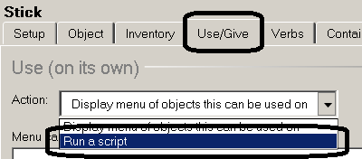
- Now select the ‘print a message’ command:
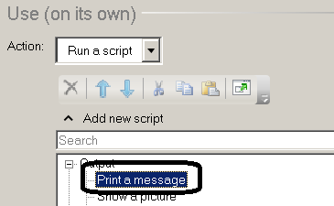
- Enter the description below:
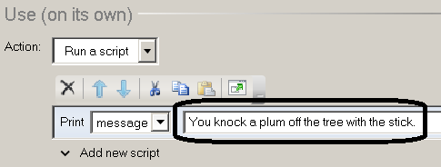
- Now play the game, pick up the stick, take it to the tree and then use the stick:
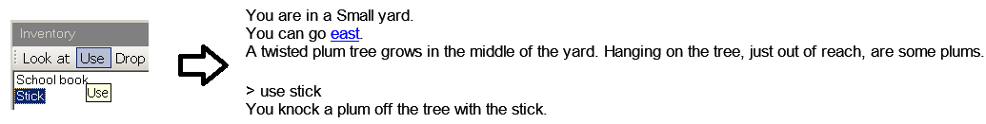
- This looks great – except for one BIG problem. Where’s the plum?
- Stop the game.
- Add a new object called ‘Plum’ in the Small yard, with a description of ‘A slightly withered looking fruit, but it still looks tasty.’
- Don’t forget to make sure that the Plum can be taken.
- Now we have a problem – because the plum is already there for the player to take it. So let’s use a bit of magic and make it invisible, so the player can’t see it – and therefore can’t take it. Untick the ‘Visible’ option in the Plum setup tab:
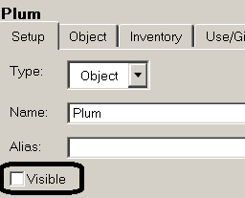
- Play the game and go to the Small yard – the plum isn’t there, so you can’t take it.
Note: Even if you type in a command – which I haven’t shown you – at the bottom left, saying ‘get plum’, then it will say ‘I can’t see that’.
- So now we want to make the plum visible when we ‘use’ the stick. Open the Stick, Use/Give tab.
- Underneath the ‘print a message’ that we added earlier, click on ‘Add new script’:
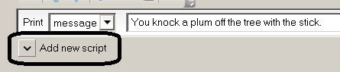
- Scroll down the right hand side and DOUBLE click on ‘Make object visible’:
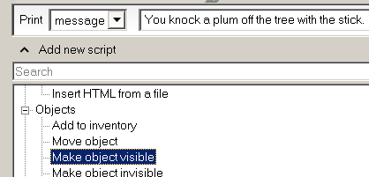
Note: if you can’t find it, then click on the little ‘-‘ in a box next to ‘Output’.
- Select the ‘empty’ drop down and choose the plum:
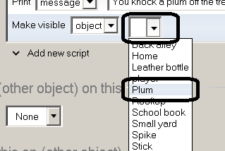
- Bingo – we’ve done it. Now Play the game:
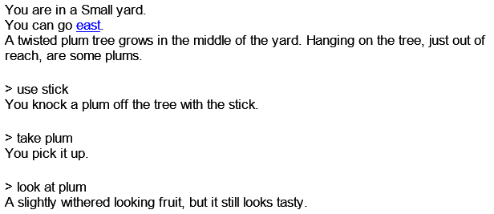
- Pat yourself on the back (not too hard) for a job well done.

Using an object part 2
Ok, I’m sorry but you haven’t finished yet.
The problem is that whenever you use the stick, it will make the plum visible and say the message:
- Go east (to the back alley) and Use the stick. You will get the message ‘You knock a plum off the tree with the stick.’ But there is no plum tree here!
- So we need to add a condition, we want to say ‘when the player is in the Small yard and she/he uses the stick, then the plum can be shown’. To do this, we need to use an ‘if’ script.
- Open up the Use/Give tab for Stick and select Add new script (as before).
- This time, type ‘if’ into the ‘search’ box and click on the little magnifying glass icon:
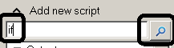
Note: You can also press the ‘Enter’ key on the keyboard instead of clicking the magnifying glass icon.
- DOUBLE click the ‘If…’ option:
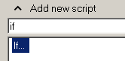
- Now change the ‘condition’ from expression to ‘player is in room’:
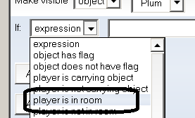
- Now pick the ‘Small yard’ from the right most drop down:
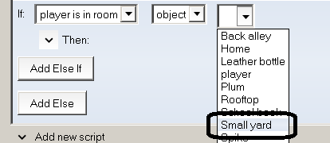
- Now select ‘Then’ to choose what to do when the player is in the Small yard:
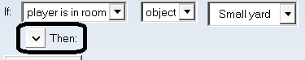
- Select ‘Print a message’ and then type in ‘You knock a plum off the tree with the stick.’
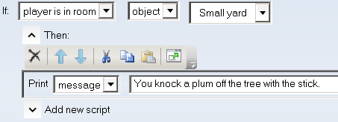
- Now we need to delete the original message, so click on the original message where it says ‘print’:
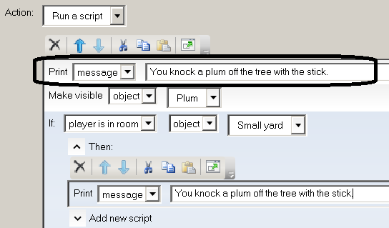
- Make sure that the print command is selected – the background will be a bit more blue:
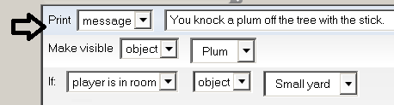
- Delete the original message by clicking the ‘X’:
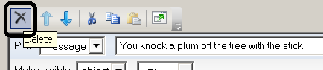
Note: If it goes wrong, then use the ‘Edit’ menu and select ‘Undo’:
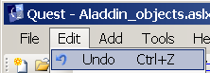
- Now we can also ‘cut’ or move a command. You may have done this is in a word processor or by ‘cutting’ out a drawing and ‘pasting’ it somewhere.
- Select the ‘make visible’ command that we created earlier and select the ‘scissors’ icon to cut the command:
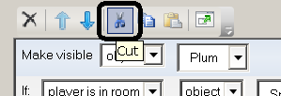
- Now click on ‘Then’:
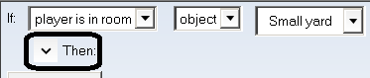
- Now click on the ‘Paste’ icon (it’s meant to be a clipboard of ‘cut’ pieces of paper ):
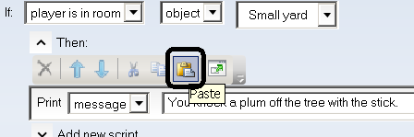
- The ‘make visible’ will be shown as the next command after the message:
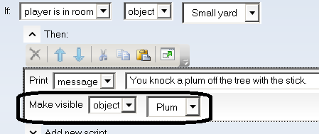
- Now Play the game
Note: There is still a problem with this – but it is beyond this workshop to solve it. Can you work out what the problem is?
Hint: The next set of instructions may help you.
Open your game and add at least one ‘useable’ object.

Adding a score
It would be nice for the player to get some feedback that they are getting somewhere in the game. Quest already allows you to include a score, which you can change using commands (i.e. scripts):
- Showing a score is quite easy. Select the game (in the objects list) and then the Options tab.
- Tick the ‘Show player score’ option:
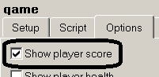
Note: There is an option to ‘Use “You are in” prefix’ at the bottom of the page – you might prefer to untick it.
- Play the game. You will see that your score is now shown, on the right, under your Inventory:
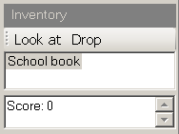
- At the moment, you can’t earn any score, so your score will stay at ‘0’.
- Let’s give the player 5 points for trying to look at the school book.
- Select the school book, the ‘Setup’ tab.
- Now change the “Look at” object description to ‘run script’:
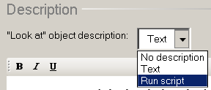
- Now add a ‘print a message’ to the script:
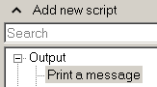
- Add the text back into the print message:
- Now ‘Add a new script’ again. Type ‘score’ in the search box and press ‘Enter’. Double click ‘Increase score’:
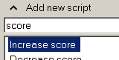
- Now change the value to say ‘10’:
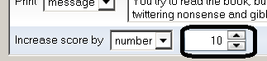
- Play the game:
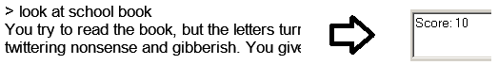
- Excellent. Yippee. Send off the fireworks. Try it again.
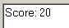
- Oh dear.
- Fortunately the solution is not tricky. We just need to tell Quest to only do this the first time.
- Stop the game
- Go back to the script for the school book.
- Add a script and search for ‘first’, then select ‘The first time’ and select ‘Run script’. Add the score increase (like before – or cut and paste it if you prefer) so you end up with:
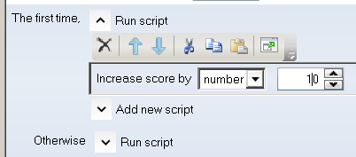
- Now delete the original increase score (if you didn’t cut and paste it).
- Play the game.
- Look at the school book twice.
- Congratulate yourself – send off the rockets and get ready to create your own objects.
Open your game and add a score for something.

Enhance your game

Design your own objects and puzzles
Note: Please start this task when you finish the above tutorial
Use the table below to design the objects that you will have in your adventure.
Name  (starting location) | Purpose/puzzle | Description/drawing
Use the table below to design your puzzles:
Description | Location/objects | Notes
Next - Open your game and add your objects and then your puzzles.

Optional - Using objects to unlock exits

N.B. This is an advanced example. You may prefer to do this later and not worry about having this kind of puzzle at the moment.
Let’s say that we want a puzzle for getting back onto the Rooftop from the Back alley:
- Change the description of the Back alley to say ‘The smooth mud wall of your home rises above your head.’
- Now select the Back Alley exit to the rooftop:
- Select the Exit tab, then tick the ‘Locked’ option and type in the ‘Print message when locked’ as below:
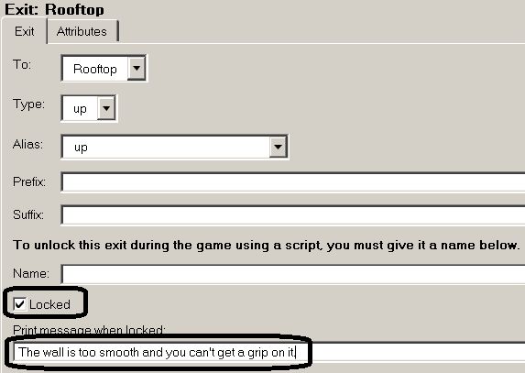
- Play the game and try and go back up to the rooftop:
- Stop the game
- Add a new object called ‘Spike’ in the Back alley with a description of ‘An brass spike that could be used to make holes in mud walls.’
- Select the ‘Inventory’ tab.
- Tick the ‘Object can be taken’.
- Select the ‘Use/Give’ tab and choose action ‘Run a script’:
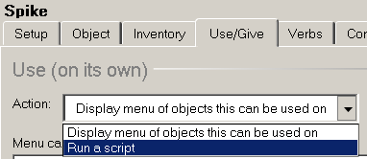
- Double click ‘Print a message’:
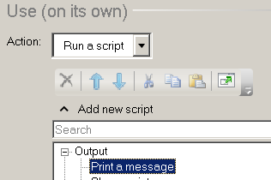
- Type in the message below:
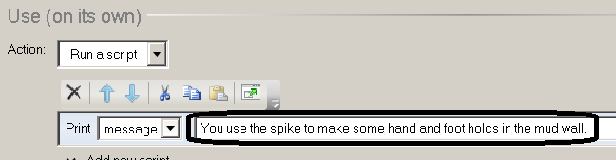
- Play the game and use the spike:
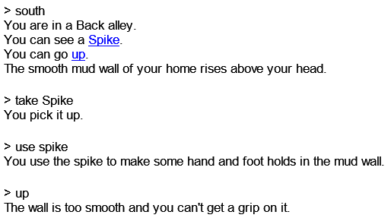
- Oh well – we need to ‘unlock’ the exit, so stop the game.
- Click on the ‘Exit: Rooftop’ (in the Back alley).
- Add a Name to the exit (just under the ‘To Unlock this exit…’):
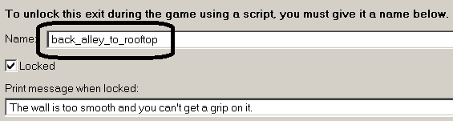
Note: this will also rename the exit from ‘Exit: Rooftop’ to ‘back_alley_to_rooftop’ in the Objects list.
- The exit is still ‘locked’, we need to tell Quest when to unlock it – i.e. when we ‘Use’ the ‘Spike’.
- Select the Spike, then the Use/Give tab.
- Click on the ‘Add new script’ just under our previously entered ‘print message’:
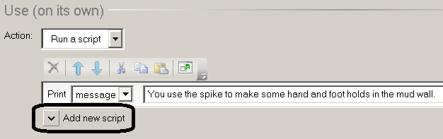
- We don’t know the command we want, so let’s search for an ‘unlock’ command. Type in ‘unlock’ in the search box, and either press ‘Enter’ or click on the find icon:
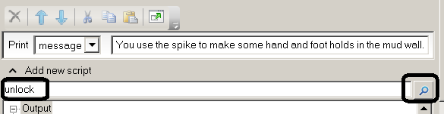
- Double click on ‘unlock exit’ (or click unlock exit and click ‘Add’ much further down the page):
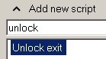
- We now have an ‘unlock’ command available for Quest:
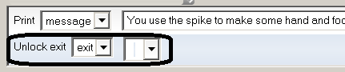
- From the second drop down, choose the only option ‘back_alley_to_roof’:
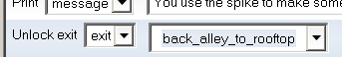
- Phew . Now Play the game:
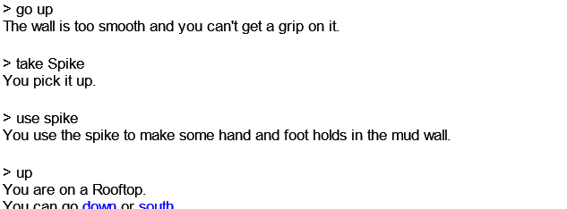
- Congratulate yourself
Next - open your game and add a puzzle based exit.

Finally
There is a lot more to Quest than we have been able to cover in this workshop. Have a look at documentation on the web site (textadventures.co.uk). There is a very good beginner’s guide that will tell you more about how Quest works. There are also lots of tutorials and step by step guides for different features of Quest. If you want to, you can also join a forum where you can ask questions and give answers.
There are other text adventure writing tools, such as Inklewriter, which offers a ‘game book’ like approach and runs in a web browser. There is also an editor called Inform 7, but this is quite tricky to use, so I wouldn’t recommend it to start.
For playing adventures, I would recommend looking at ‘colossal cave’ as an example of a historic game. There is also Zork, which was written by Infocom – probably one of the first game companies. Most Infocom games are worth playing. The Hitchiker’s guide to galaxy game is a classic and was written with Douglas Adams, who wrote the book. A good way to find these game sis to search for their name and ‘play online’. You can also get apps, such as ‘twisty’, which let you play games, but this is beyond this workshop to describe.
I hope that you have enjoyed this workshop and can see the richness available from text games, which though out of date, still underpin many of the games out there now, such as Mass Effect, Zelda, Pokemon, etc.

